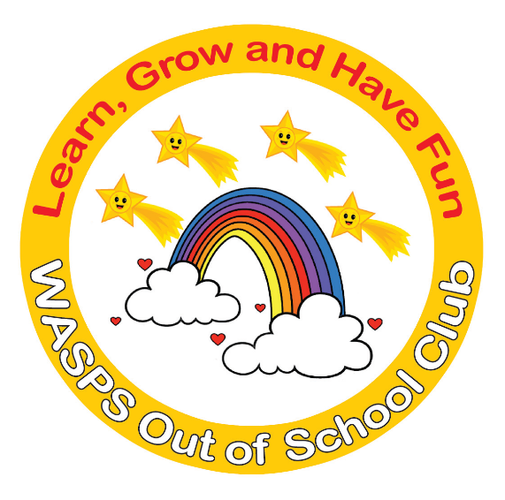
WASPS Out of School Club
A warm and safe environment where children aged 3 to 13 learn, grow and have fun!

BREAKFAST CLUB CONTRACT

Child Details

Name of Child: ………………………………………………………………………………………………………………………….
Date of Birth: ………………………………………………………………………………………………………………………….
Home Address: ………………………………………………………………………………………………………………………….
………………………………………………………………………………………………………………………….
………………………………………………………………………………………………………………………….
Home Telephone Number: ………………………………………………………………………………………………….
Mobile Number: ………………………………………………………………………………………………………………………….

Please circle days and times required
MONDAY | 07.30-08.50 | 07.45-08.50 | TAKE TO SPINS  09.00
TUESDAY | 07.30-08.50 | 07.45-08.50 | 09.00
WEDNESDAY | 07.30-08.50 | 07.45-08.50 | 09.00
THURSDAY | 07.30-08.50 | 07.45-08.50 | 09.00
FRIDAY | 07.30-08.50 | 07.45-08.50 | 09.00

Sessions run from 07.45am to 08.50am with staff taking children to Roger de Clare School and Ralph Sadleir School by means of a walking bus at 08.30am and children to St Thomas of Canterbury School, Hormead and Jenyns School by car at 08.30am.

07.45am-08.50am £7.50 (also on occasional basis booked 1 wk in advance and paid for at time of booking)
07.45am-08.50am £9.00 (also on occasional basis booked under 1 wk in advance and paid for at time of booking)
07.30am-7.45am £2 (also on occasional basis booked 1 week in advance and paid for at time of booking)
07.30am-7.45am £2.50 (also on occasional basis booked under 1 week in advance and paid for at time of booking)
Nursery children taken to SPINS nursery will be charged an extra £1.
Car drop of at school will be charged at a rate of £2 per child per trip.
10% discount for 2nd child if you have 2 or more children attending.

Fees are due on the 1st of the month in advance, for all sessions booked. Invoices will be handed out or posted on the first day of the month allowing one month to settle their account in full for the following months fees. WASPS Out of School Club operates a non-refund policy. Late payment of invoices will incur a penalty of £1 per day. Parents who are consistently late in making payments will incur a suspension of their child from the setting until all monies are settled in full.

To allow children time to eat breakfast before school, they have to be at breakfast club by 08.15am at the latest (08.00am during COVID pandemic). Children who arrive after this time will not be offered breakfast. WASPS Out of School Club should be informed of any absences by 07.30am. Failure to do so will result in a penalty fee of £2. Termination of the contract either side will be 4 week’s notice in writing.

All of WASPS policies and procedures file is available to all parents. Should you wish to view them or would like a hard copy of any policy, please ask a member of staff.

I am required by Ofsted to inform you that if you should have any complaints or compliments regarding WASPS Out of School Club then you will need to follow procedures as set out in our Complaints and Compliments Policy.

I acknowledge all of the above, have read the Admission and Fees Policy and Terms and Conditions Booklet and agree with the terms and conditions of the contract.

Signature of Parent: ………………………………………………………………………………………………………………

Print Name: ………………………………………………………………………………………………………………

Date: ………………………………………………………………………………………………………………

Signature by WASPS Out of School Club Proprietor:

……………………………………………………………………………………………………………………………………………………………..

Date: ………………………………………………………………………………………………………………
Once completed and returned to WASPS, a copy of this contract will be returned to you for your information.

