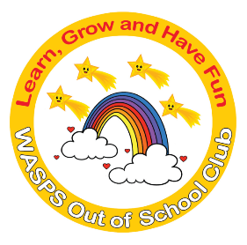
WASPS Out of School Club
A warm and safe environment where children aged 3 to 13 learn, grow and have fun!
OCTOBER PLAY SCHEME 2020
At Standon and Puckeridge Community Centre
Station Road, Puckeridge, Hertfordshire SG11 1TF

Half-Day session per child is £12 (8am-1pm or 1pm-6pm)
Full-Day session per child is £23 (8am-6pm)
Discount for 2 or more children from the same family

Monday 26th October | Am  Sand Art  Dodgeball  Nature Collages | Pm  Make Origami Animals  Make Chocolate Crispy Cakes  Visit Park
Tuesday 27th October | Am  Make Scarecrow Puppets  Play Team Games  Make Wands | Pm  Table Football  Outdoor Scavenger Hunt (Weather permitting)  Make Clay Animals
Wednesday 28th October | Am  Table Tennis Competition  Make and Decorate Cakes  Make Stress Balls | Pm  Hama Bead Creations  Den Building  Make Paper Plate Animals
Thursday 29th October | Am  Face Painting  Basketball  Nature walk to Collect Conkers and Leaves | Pm  Penalty Shoot Out  Film and Popcorn  Make Conker Creatures
Friday 30th October | Am  Halloween Face Painting  3D Modelling  Make Halloween Decorations to take home | Pm  Make Slime  Talent Show  Visit to the Park  (Weather permitting)
Please ensure children have appropriate clothing for messy and wet activities and warm clothing should we go outside. This schedule is just a guide and children will have a choice to participate in these activities or choose some activities of their own.
All children need to bring in packed lunch and snacks for the day. Water will be provided. No other food will be served during the day.
For further details or a booking form, please call Nicola on 07904391133, download booking from our website www.waspsclub.com or email nicola@waspsclub.com. Or you can call into the Community Centre between 2.30pm and 6.15pm to collect a booking form.

