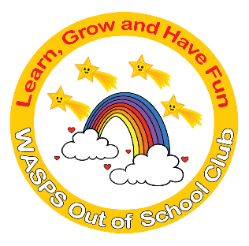
WASPS Out of School Club
A warm and safe environment where children aged 3 to 13 learn, grow and have fun!

BREAKFAST CLUB, AFTER SCHOOL AND PLAY SCHEME OPENING AND CLOSING DATES FOR 2021/2022
UPDATED MAY 2021 – DRAFT VERSION

We will be open on the following dates

2021
Friday 7th May – Thursday 27th May
Monday 7th June – Wednesday 21st July (1.15pm Collection RC/1.30pm ST/1.30pm RS/3.20 J)
PLAY SCHEME – Monday 9th August – Friday 13th August (08.00am-6.00pm)
PLAY SCHEME – Monday 16th August – Friday 20th August (08.00am-6.00pm)
PLAY SCHEME – Monday 23rd August – Friday 27th August (08.00am-6.00pm)
Thursday 2nd September – Friday 22nd October
PLAY SCHEME Monday 25th October – Friday 29th October (08.00am-6.00pm)
Monday 1st November – Thursday 2nd December
Monday 6th December – Tuesday 21st December (1.15pm Collection RC/1.30pm ST/1.30pm RS)

2022
Thursday 6th January – Friday 11th February
PLAY SCHEME Monday 14th February - Friday 18th February(08.00am-6.00pm)
Monday 21st February – Friday 1st April (1.15pm Collection RC/1.30pm ST/1.30pm RS/12.15 J)
PLAY SCHEME Monday 4th April – Friday 8th April (08.00am-6.00pm)
PLAY SCHEME – Monday 11th April – Thursday 14th April (08.00am-6.00pm)
Wednesday 20th April – Friday 29th April
Tuesday 3rd May – Wednesday 4th May
Friday 6th May – Thursday 26th May
Monday 6th June – Thursday 21st July (1.15pm Collection RC/1.30pm ST/1.30pm RS/3.20 J)
PLAY SCHEME – Monday 8th August – Friday 12th August (08.00am-6.00pm)
PLAY SCHEME – Monday 15th August – Friday 19th August (08.00am-6.00pm)
PLAY SCHEME – Monday 22nd August – Friday 26th August (08.00am-6.00pm)

We will be closed on the following dates

2021
Friday 28th May (RC, RS Inset Day)
Monday 31st May – Friday 4th June (Whitsun)
Thursday 22nd July – Friday 6th August (Summer Holidays)
Monday 30th August (Bank Holiday)
Tuesday 31st August (ST, RS, J Inset Day)
Friday 3rd December (RS, J, RC Occasional Day)
Wednesday 22nd December – Wednesday 5th January (Christmas Holidays)

2022
Friday 15th April (Good Friday)
Monday 18th April (Easter Monday)
Tuesday 19th April (RS, ST Inset Day)
Monday 2nd May (May Day)
Thursday 5th May (Hall Closed for Elections)
Friday 27th May (RC, RS Inset Day)
Monday 30th May – Friday 3rd June (Whitsun)
Friday 22nd July – Friday 5th August (Summer Holidays)

PLEASE NOTE THAT THESE DATES MAY ALTER SLIGHTLY IF SCHOOLS INTRODUCE MORE INSET OR OCCASIONAL DATES FOR 2021/2022

