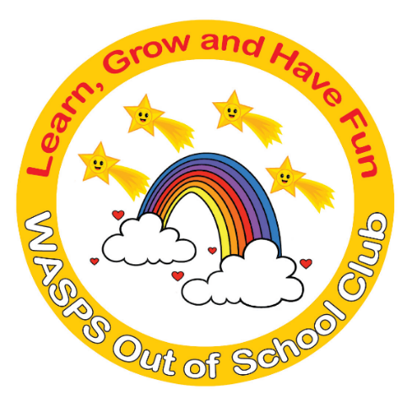
WASPS Out of School Club
A warm and safe environment where children aged 3 to 13 learn, grow and have fun!

Coronavirus Policy
WASPS Out of School Club recognises the importance of advanced planning in order to maintain services and limit the spread of the new coronavirus within our setting.
The new coronavirus is a viral infection similar to flu, spread from person to person by close contact. It typically causes fever and a cough, and in some cases may progress to viral pneumonia which cannot be treated by antibiotics. Symptoms of coronavirus can include:
Cough | Sore throat
Fever | Tiredness
Difficulty breathing
The initial symptoms are similar to other colds and flu-type illnesses – the key questions are whether the patient has travelled to a high-risk area in the last two weeks or been in contact with a person who has.
Any child who becomes ill with symptoms which could be coronavirus while at the Club will be isolated from the other children by at least two metres until the child can be collected by his or her parents. The Club will remain open, but parents and staff will be informed, especially those in high-risk groups.
Should any children or staff experience symptoms of coronavirus they should stay away from the Club until all symptoms have passed and they feel well.
If any staff or children have returned from a high-risk area, they will be asked to stay away from the Club for 14 days from their date of return.

Infection control

Like the common cold and other flu viruses, the new coronavirus is spread by:

Infected people passing the virus to others through large droplets when coughing, sneezing, or even talking within a close distance.
- Direct contact with an infected person: for example, if you shake or hold their hand, and then touch your own mouth, eyes or nose without first washing your hands.
- Touching objects (e.g. door handles, light switches) that have previously been touched by an infected person, then touching your own mouth, eyes or nose without first washing your hands. Viruses can survive longer on hard surfaces than on soft or absorbent surfaces.
We will limit the risk of catching or spreading the new coronavirus at the Club by:
- Regular handwashing by staff and children
- Minimising contact between our hands and mouth/nose
- Covering nose and mouth when coughing or sneezing; using a tissue when possible, and disposing of the tissue promptly and carefully (bag it and bin it)
- Cleaning hard surfaces (e.g. door handles, light-switches, tables, etc) with sanitizer frequently
- Encouraging the children at the Club to follow the guidance above
- Instructing staff to remain at home if they display any relevant symptoms or sending them home if they first display symptoms while at work.
At WASPS Out of School Club we will promote infection control through the methods above, and in addition we will:
- Display posters and information to promote infection control
- Ensure that adequate supplies of cleaning materials are available within the Club
- Dispose of waste promptly and hygienically
- Provide tissues and suitable facilities for their disposal.

Closure
The latest advice is that closing individual settings is of limited benefit in stopping the spread of the disease. However, there may be some occasions when we will have to consider temporarily closing the Club because we have too few unaffected staff to run sessions safely. If this occurs the manager will contact local Early Years or Childcare service for further support and guidance.
The Club will also have to close if advised to do so by the local authority in the interest of safeguarding the children in our care.
In the event of closure, the manager will notify parents or carers as soon as possible. The manager will also inform the local Early Years or Childcare service as well as other relevant parties, e.g. feeder schools, other users of shared premises, etc. The manager will also notify Ofsted of the closure.

Advance planning
In preparation for dealing with a pandemic disease, the Club will ensure that all contact details for staff, children and parents are up to date.
We will prepare letters of notification for parents and staff, so that they can be distributed immediately if an outbreak occurs.
We will endeavour to build a bank of relief or supply staff who are able to provide cover should staffing levels fall below the required legal minimums. Any relief staff will be DBS checked at the time of joining our team, so that they are legally able to work with children should the situation arise.
The Club will regularly update its information regarding pandemic diseases, by checking the latest guidance from Public Health England and the local authority and will inform parents and staff of any changes to our emergency plans.
Useful contacts
Early Years or Childcare Service: 01438 845111
Ofsted: 0300 123 1231
Health Protection Team (HPT): 0300 303 8537 Option 1

This policy was adopted by: WASPS Out of School Club | Date: February 2020
To be reviewed: February 2021 | Signed: N J ENGLISH

Written in accordance with the Statutory Framework for the Early Years Foundation Stage (2017): Safeguarding and Welfare Requirements: Health [3.44].

